**Lab 11**

**Laboratory Exercise**

**Part 1: Nagios Versions**

**Let take a look at the differences between Nagios Core and Nagios XI. View this YouTube video.**

[**https://www.youtube.com/watch?v=vUDWi5tjqPQ**](https://www.youtube.com/watch?v=vUDWi5tjqPQ)

**LAB EXERCISE**

This lab will cover Nagios installations and preparations.

**Time to Complete**

Approximately 25 Minutes

**What You Need**

You’ll need an installed Ubuntu 18.04 system for this tutorial.

**Virtual Machines**

1. From your machine logged-in to RP VPN, run Remote Desktop Connection to connect to the ubuntu Linux Virtual Machine (VM). Please login based on your assigned VM as shown below:

|  |  |  |  |  |  |
| --- | --- | --- | --- | --- | --- |
| **S/N** | **Name** | **VM** | **IP Address** | User Name | Password |
| 1 | LEOW TANG QING | PDC2-Ubuntu-02 | 172.20.113.136 | soi-sddo | Republic01 |
| 2 | LIM SHEN HUI | PDC2-Ubuntu-03 | 172.20.113.137 | soi-sddo | Republic01 |
| 3 | LIN JINGZHOU | PDC2-Ubuntu-04 | 172.20.113.138 | soi-sddo | Republic01 |
| 4 | MUHAMMAD FAISAL BIN SHAIK HASSAN | PDC2-Ubuntu-05 | 172.20.113.139 | soi-sddo | Republic01 |
| 5 | LYNN LEE QING XIA | PDC2-Ubuntu-06 | 172.20.113.140 | soi-sddo | Republic01 |
| 6 | NG CHEE KIONG | PDC2-Ubuntu-07 | 172.20.113.141 | soi-sddo | Republic01 |
| 7 | PARAMASIVAM S/O VANNU GOPAL | PDC2-Ubuntu-08 | 172.20.113.142 | soi-sddo | Republic01 |
| 8 | SAHLATUL-FARIHAH BINTE M ASARI | PDC2-Ubuntu-09 | 172.20.113.143 | soi-sddo | Republic01 |
| 9 | SHAIKH FAID BIN OMAR | PDC2-Ubuntu-10 | 172.20.113.144 | soi-sddo | Republic01 |
| 10 | CHIU JING XIONG | PDC2-Ubuntu-11 | 172.20.113.145 | soi-sddo | Republic01 |
| 11 | KELLY WONG XUE YEE | PDC2-Ubuntu-12 | 172.20.113.146 | soi-sddo | Republic01 |
| 12 | LIM SI YING | PDC2-Ubuntu-13 | 172.20.113.147 | soi-sddo | Republic01 |
| 13 | LIN LI YI | PDC2-Ubuntu-14 | 172.20.113.148 | soi-sddo | Republic01 |
| 14 | MUHAMMAD MUQTADIR BIN SADIQ BASHA | PDC2-Ubuntu-15 | 172.20.113.149 | soi-sddo | Republic01 |
| 15 | NUR HIDAYAH BTE RAMLEE | PDC2-Ubuntu-16 | 172.20.113.150 | soi-sddo | Republic01 |
| 16 | NUR NADIA ASHBOLLAH BINTE | PDC2-Ubuntu-17 | 172.20.113.151 | soi-sddo | Republic01 |
| 17 | NUR THAQIFAH AQILAH BINTE JURAIMI | PDC2-Ubuntu-18 | 172.20.113.152 | soi-sddo | Republic01 |
| 18 | RAUDHATUNNISHA BTE RAMLI | PDC2-Ubuntu-19 | 172.20.113.153 | soi-sddo | Republic01 |
| 19 | SITI NUR ALYSHYIA BINTE HASHIM | PDC2-Ubuntu-20 | 172.20.113.154 | soi-sddo | Republic01 |
| 20 | TAN TEE BING | PDC2-Ubuntu-21 | 172.20.113.155 | soi-sddo | Republic01 |
| 21 | CHIU JING XIONG | PDC2-Ubuntu-22 | 172.20.113.156 | soi-sddo | Republic01 |

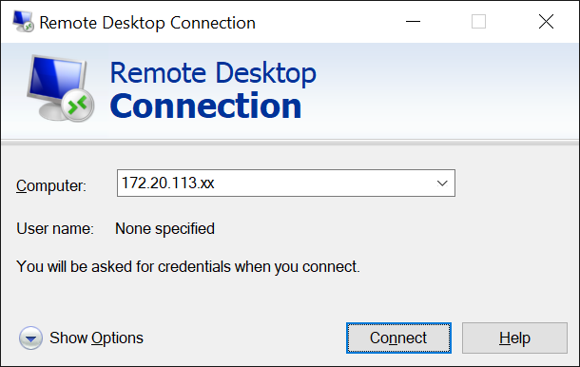

Replace xx with the IP address of the VM that you have been assigned.

**First time login**

1. Launch a terminal and check your ubuntu version:

lsb_release -a

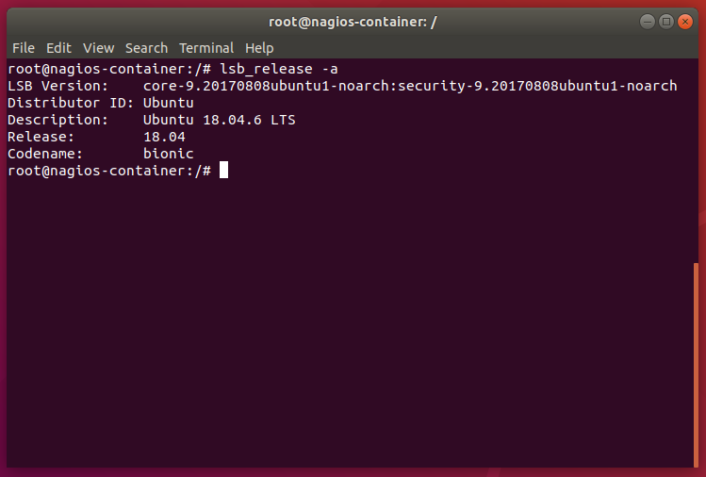

**Update the repositories**

2. The first step is to upgrade and update the repositories. Updating the packages will download the list of packages with their latest version while upgrading the packages will install the latest version of the packages as mentioned in the list:

sudo apt update && apt upgrade

**Install the LAMP stack**

3. Before installing the Nagios tool, it’s important to install the LAMP stack. LAMP is a collection of Linux Apache MariaDB and Python/PHP/Perl which is used for dynamic websites:

sudo apt-get install -y autoconf gcc libc6 make wget unzip apache2 php libapache2-mod-php7.2 libgd-dev

4. Check your Apache status:

sudo systemctl status apache2

|  |
| --- |
| <Insert screen capture of results> |

5. You can download the latest Nagios core from: <https://www.nagios.org/downloads/>

6. Or use this embedded file (right-click, copy and paste into your ubuntu):



7. Save the file into your /tmp directory and extract it:

|  |  |  |
| --- | --- | --- |
|  | cd /tmp | |
|  | tar xzf nagioscore.tar.gz |

**Compile the package**

8. To install Nagios on Ubuntu after downloading and extracting the tarball, we need to compile the package. Change the current directory to the Nagios directory and run the configure script. The configure script is used to check whether all the dependencies are present in the system or not. Let’s have a look at the command below:

|  |  |
| --- | --- |
|  | cd /tmp/nagioscore-nagios-4.4.5/  sudo ./configure --with-httpd-conf=/etc/apache2/sites-enabled |

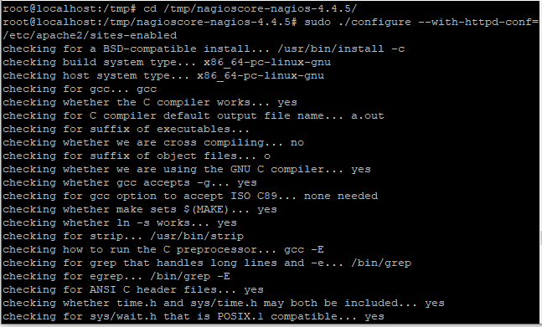

9. The next step is to build nagios using the make command. Type the following in the terminal:

|  |  |
| --- | --- |
|  | sudo make all |

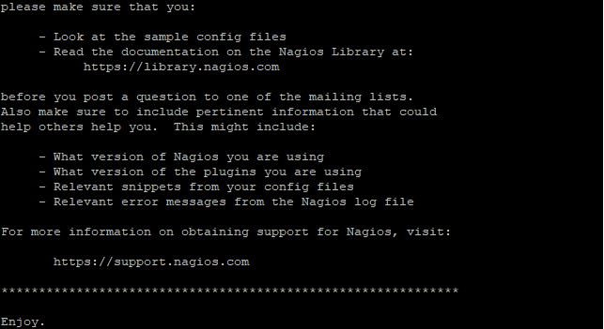

**Create a group and a user**

10. We need to create a group and a user for Nagios. Create the Nagios user account and add it to the group:

|  |  |
| --- | --- |
|  | sudo useradd nagios  sudo groupadd nagios |

Once the group and user is created, add the www-data user to the nagios group so we can run Nagios and access the application from the webserver.

|  |  |
| --- | --- |
|  | sudo usermod -a -G nagios www-data |

**Install the Nagios plugins**

11. Earlier we discussed that it is important to install the Nagios plugins to interact with the host computer. These are the executable files. Therefore, download the latest version of the plugin. It will be downloaded in the tar file, extract it later using tar command. Do change the directory to tmp folder. Use the[wget command](https://www.linuxfordevices.com/tutorials/linux/linux-wget-command) to install the plugins.

Let’s have a look at the command below:

cd /tmp

wget --no-check-certificate -O nagios-plugins.tar.gz https://github.com/nagios-plugins/nagios-plugins/archive/release-2.2.1.tar.gz

12. Extract the archive using tar command. To do so, type the following in the terminal

|  |  |
| --- | --- |
|  | tar zxf nagios-plugins.tar.gz |

**Monitored Clients**

**Part 2: Install Additional Clients to be monitored**

**LAB EXERCISE**

This lab will cover the installation of additional client containers.

**Time to Complete**

Approximately 20 Minutes

**What You Need**

You will need to refresh and reuse your Docker container commands from Lesson 6.

Client Containers

1. For the first client container, you shall install a Docker container with Apache web server.
2. For the second client container, you shall install a Docker container with Postgres database.
3. Record all the commands that you have used here:

|  |
| --- |
| <Your commands to create client containers> |

1. Check your Docker container status and information, and paste a screenshot here:

|  |
| --- |
| <Insert screen capture of your Docker status> |

**Monitored Clients**

**Part 3: Install and Configure SSH**

**LAB EXERCISE**

This lab will cover the installation and configuration of SSH.

**Time to Complete**

Approximately 15 Minutes

**What You Need**

You will need to have your client containers up and running.

SSH Installation and Configuration

1. Follow either of these links to install and configure openssh-server package on your client containers:
   1. <https://linuxize.com/post/how-to-enable-ssh-on-ubuntu-18-04/>
   2. <https://linuxhint.com/enable_ssh_server_ubuntu_1804/>
2. Next, follow either of these links to implement password-less SSH login to both your client containers:
   1. <https://websiteforstudents.com/how-to-setup-ssh-key-login-on-ubuntu-linux/>
   2. <https://www.linuxbabe.com/linux-server/setup-passwordless-ssh-login>

**Summary:**

* Nagios Core software downloaded and compiled.
* Nagios Plugins downloaded and compiled.
* Apache web server installed on Nagios server.
* One Apache web server client container installed.
* One Postgres database client container installed.
* OpenSSH-server package installed on both client containers.
* Password-less SSH login configured.

**--End of Lab Exercise --**